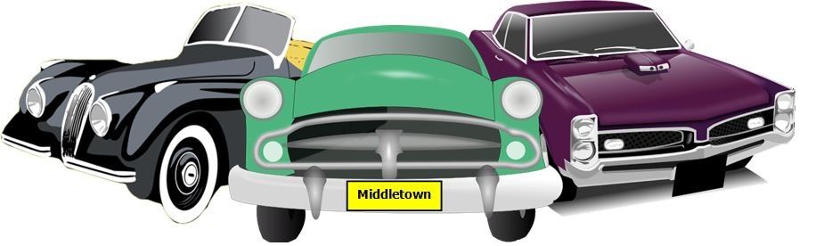

**GREAT FOOD!**

**LIVE MUSIC!**

**Pre-registration $15.00 (until 8/20/22), Day of show $20.00**

**All proceeds to benefit the King of Kings Lutheran Church**

**Any questions, please call Gerry Conte 732-600-1186**

**NO alcoholic beverages.**

**Show is open to all years, makes and models**

**Trophies awarded including Pastor’s Pick Award, and Kid’s Choice**

**Dash Plaques and Goodie Bags**

**Great Food and Refreshments available for purchase**

**Outstanding Music, Parking lot with several shaded sections**

**King of Kings Lutheran Church**

**Annual Car Show**

**Saturday, August 27, 2022 (Rain Date 9/10/22)**

**10am to 2pm (Registration opens at 9am)   
250 Harmony Road, Corner of Harmony and Cherry Tree Farm Roads   
Middletown, NJ 07748**

**50/50 DRAWING**

**PRIZES!**

**TROPHIES!**

**Car Show Registration Form**

**Make checks payable to: King of Kings Lutheran Church**

**Please mail check and completed / signed registration form to:**

**Gerry Conte PO Box 654 Keansburg, NJ 07734**

**Name: _________________________________________________________________________________________________**

**Address: _______________________________________________________________________________________________**

**City: __________________________________________ State: ______________________________ Zip: _________________**

**Vehicle Make: ____________________________________ Model: ______________________________ Year: _____________**

**Phone: _______________________________________ Email: ____________________________________________________**

**Club Affiliation: __________________________________________________________________________________________**

**I hereby release the King of Kings Lutheran Church and anyone connected with this car show, from any and all responsibility for any illness, injuries, accidents, damage or theft that may occur to me, my vehicle, or my property while at this show. I will also be responsible for all guests entering this show with me.**

**Signature: ______________________________________________ Date: _________________________**

**Sorry, No Refunds**